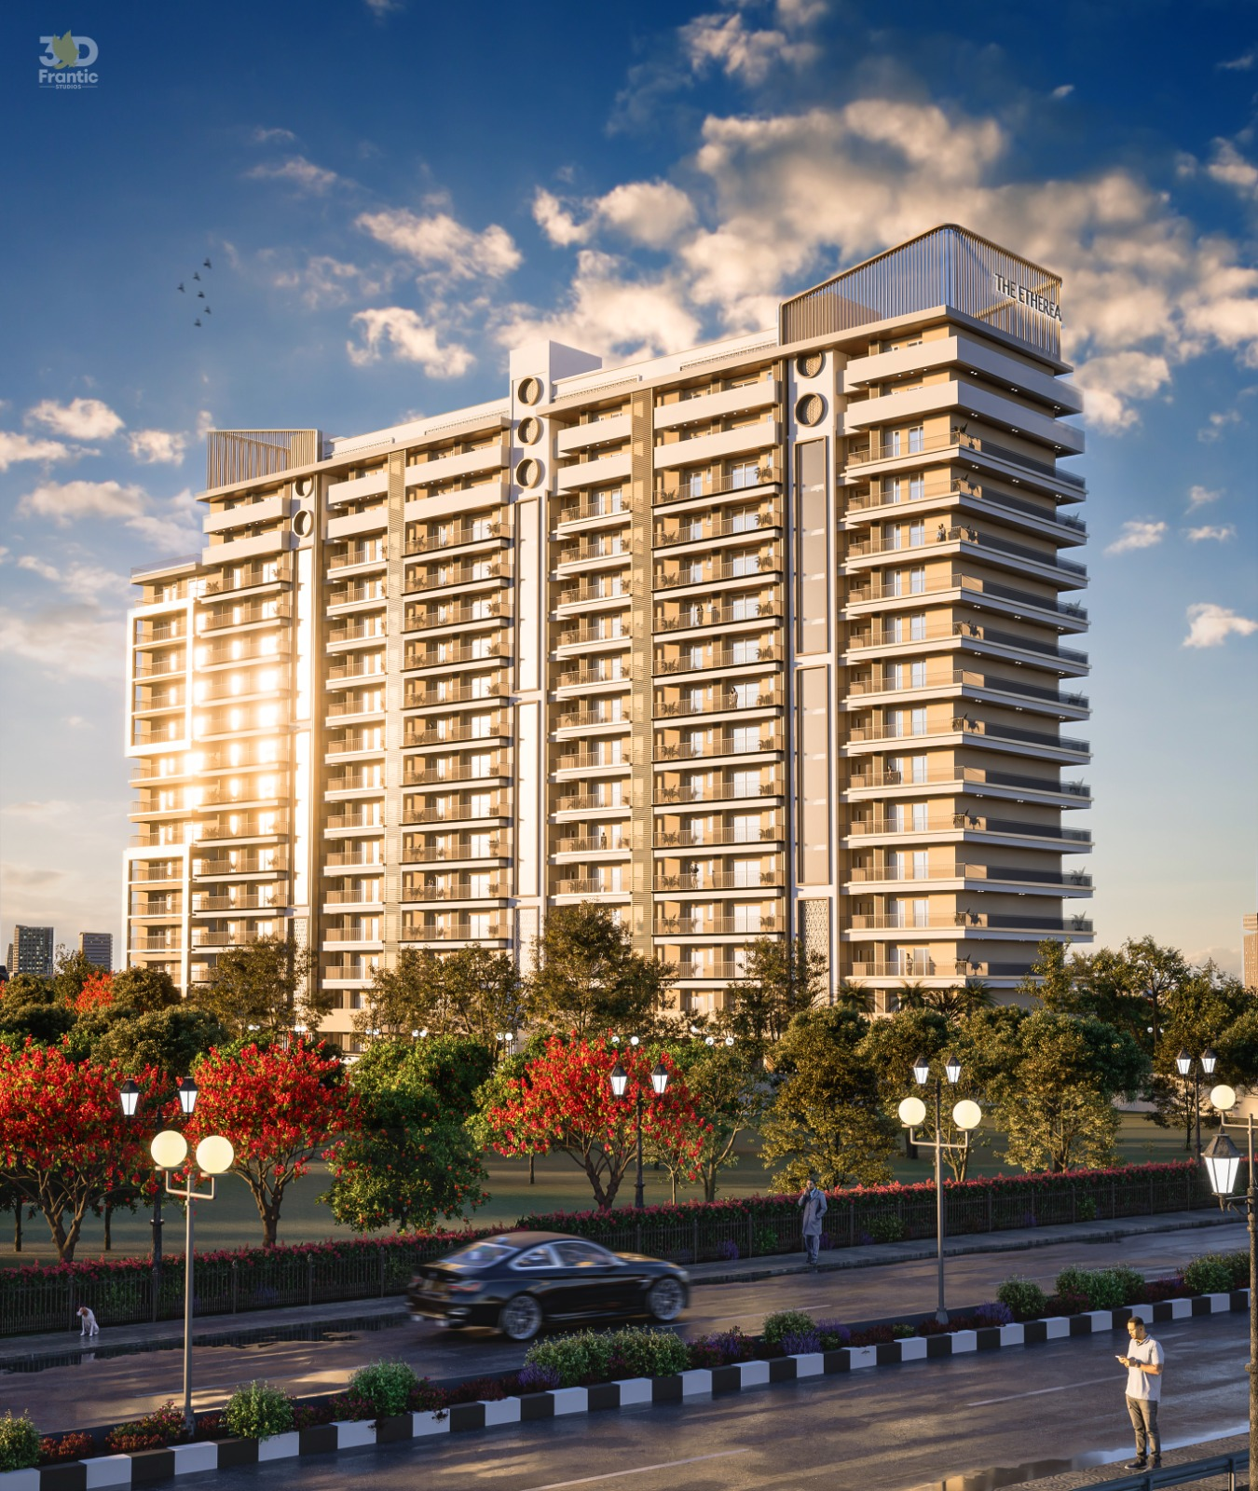

The Ethereal a Rera Approved Group Housing Residential Project by Evermark Developers
Adjoining PR7 Airport Road, Zirakpur

Premium 3 Bhk Apartments starts from 1.39cr

Majestic S+15 High-Rise Towers.
A perfect retreat for modern lifestyle, comfort, and world-class living.

Begin Your Elevated Living at The Ethereal 🏡

